# **Practical – 6**

**Aim:** **Write a program to implement K-Nearest Neighbors.**

* Code:

import numpy as np

import matplotlib.pyplot as plt

import pandas as pd

import seaborn as sns

from sklearn.model_selection import train_test_split

from sklearn.neighbors import KNeighborsRegressor

from sklearn.metrics import mean_squared_error, r2_score

data_set = pd.read_csv('/content/drive/MyDrive/temp/practical_4_2.csv')

print(data_set)

X = data_set[['Match_Duration', 'Loot_Collected', 'Enemies_Defeated']]

y = data_set['Player_Score']

X_train, X_test, y_train, y_test = train_test_split(X, y, test_size=0.2, random_state=42)

knn_model = KNeighborsRegressor(n_neighbors=3)

knn_model.fit(X_train, y_train)

y_pred = knn_model.predict(X_test)

print("Mean Squared Error:", mean_squared_error(y_test, y_pred))

print("R² Score:", r2_score(y_test, y_pred))

plt.figure(figsize=(10, 6))

sns.scatterplot(x=y_train, y=knn_model.predict(X_train), color='green', label='Training Data')

plt.xlabel('Actual Player Score')

plt.ylabel('Predicted Player Score')

plt.title('KNN: Training Data - Actual vs Predicted')

plt.legend()

plt.show()

plt.figure(figsize=(10, 6))

sns.scatterplot(x=y_test, y=y_pred, color='purple', label='Test Data')

plt.xlabel('Actual Player Score')

plt.ylabel('Predicted Player Score')

plt.title('KNN: Test Data - Actual vs Predicted')

plt.legend()

plt.show()

* Output

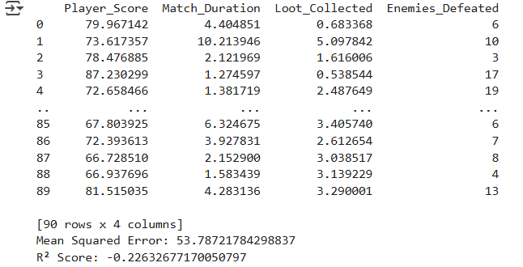

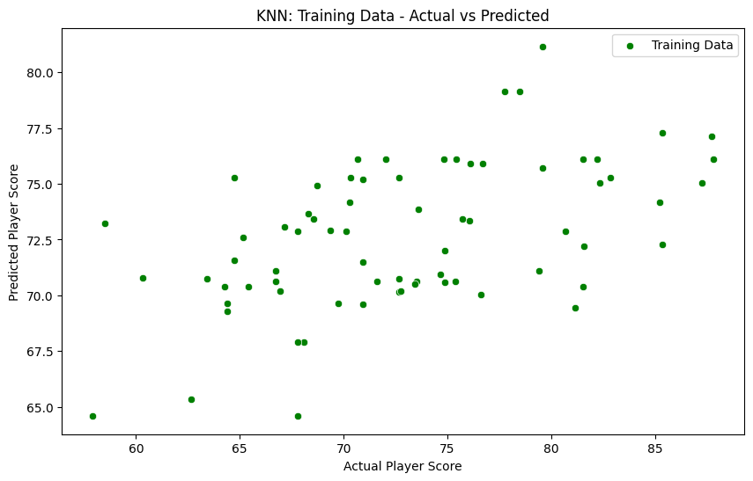

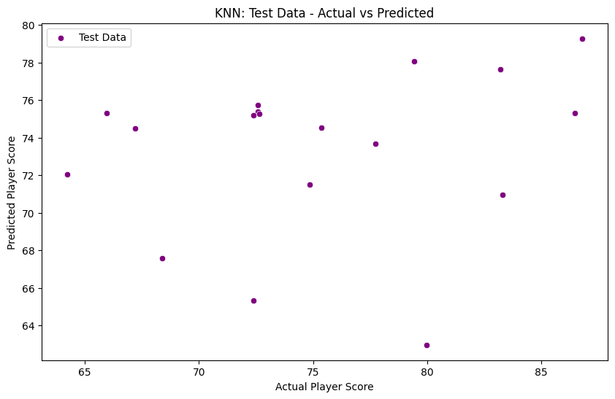

Faculty Signature: _______________ Date: _____________________